COVID-19 Social Distancing Signage
In alignment with Public Health England and Government guidelines, University departments are tasked with taking measures to prevent community spread of COVID-19 and to implement social distancing. This guidance aims to help departments with any signage they may need to help them fulfil this task.
These are word documents so can be adapted to suit your Institutions needs if necessary.

Signage

 |  | Page
1. | 2m Social distance sign | 2
2. | Do not sit here sign | 3
3. | Hand sanitiser sign | 4
4. | No entry sign | 5
5. | One way ahead sign | 6
6. | One way left sign 01 | 7
7. | One way left sign 02 | 8
8. | One way right sign 01 | 9
9. | One way right sign 02 | 10
10. | One way system sign | 11
11. | Sanitise controls sign | 12
12. | Stairs down sign | 13
13. | Stairs up sign | 14
14. | Maximum room occupancy sign | 15
15. | Floor arrows | 16
16. | Caution both ways on stairs | 17
17. | Caution both ways | 18

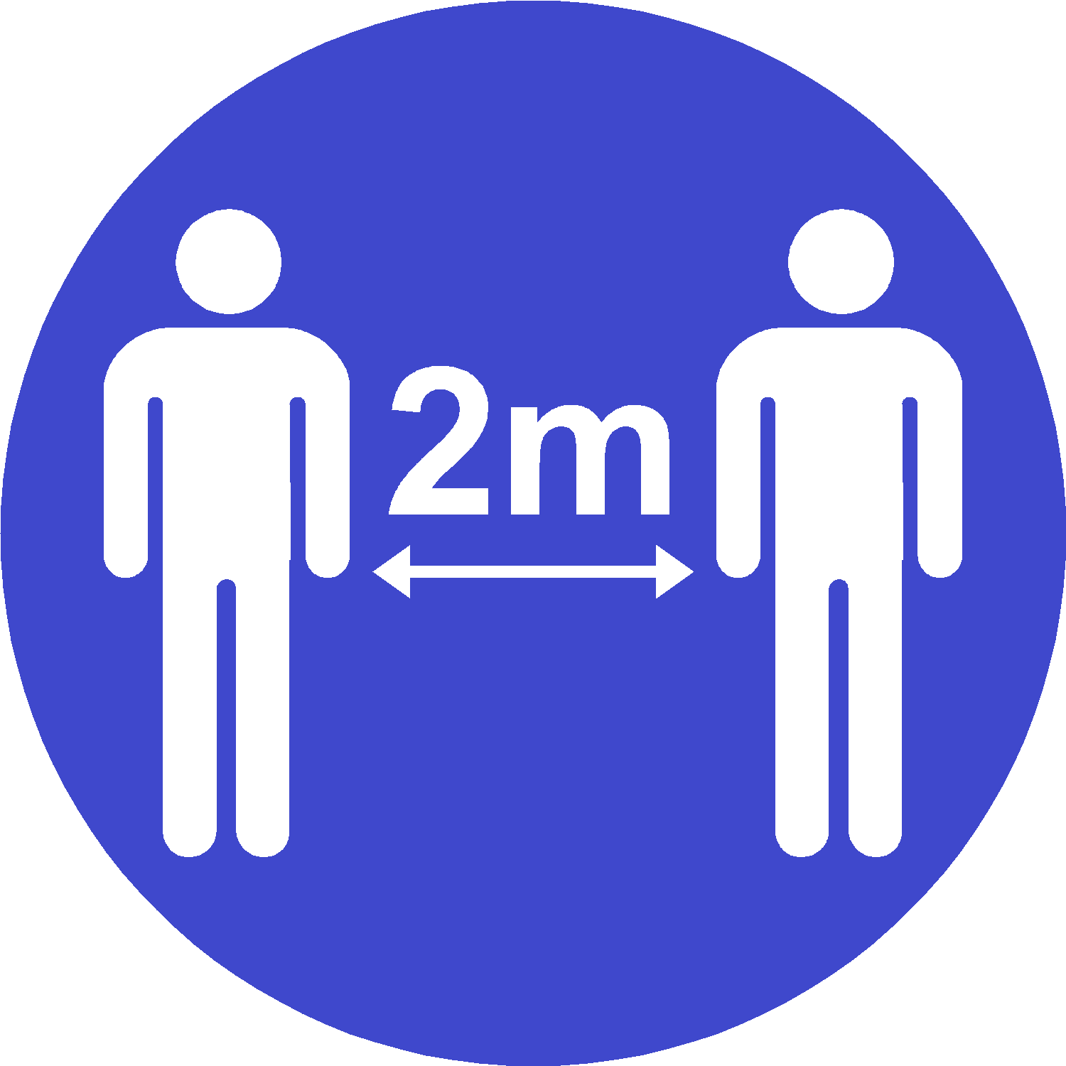
Covid-19:
Keep 2m apart

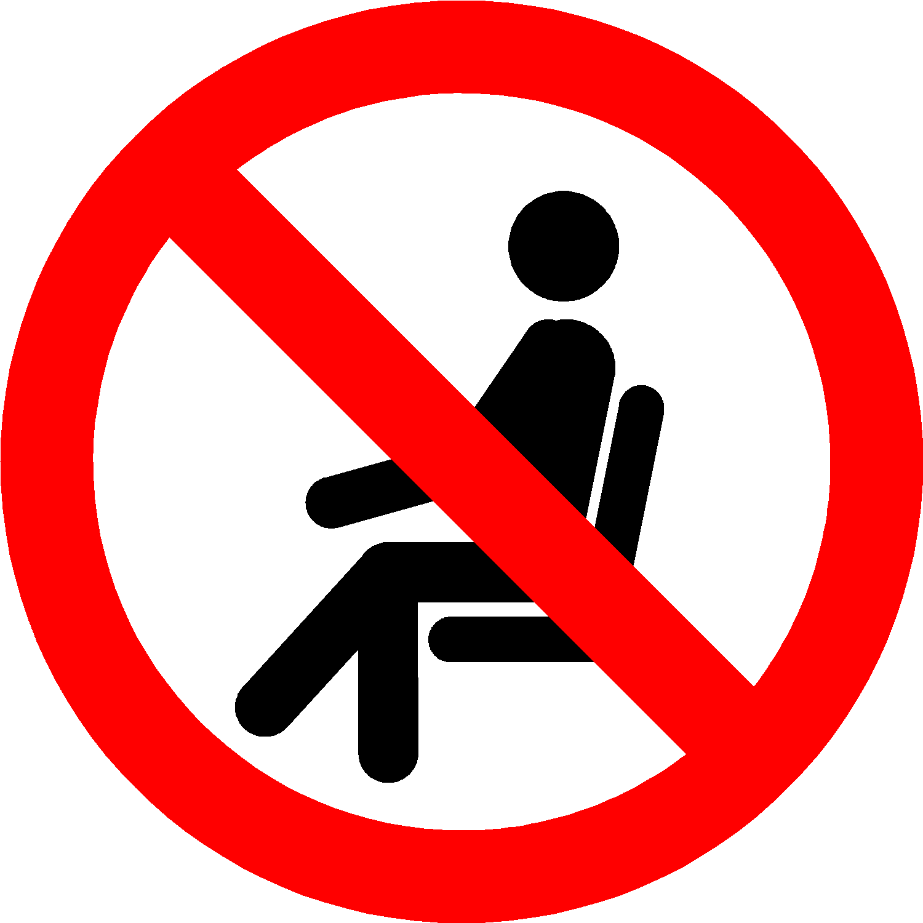
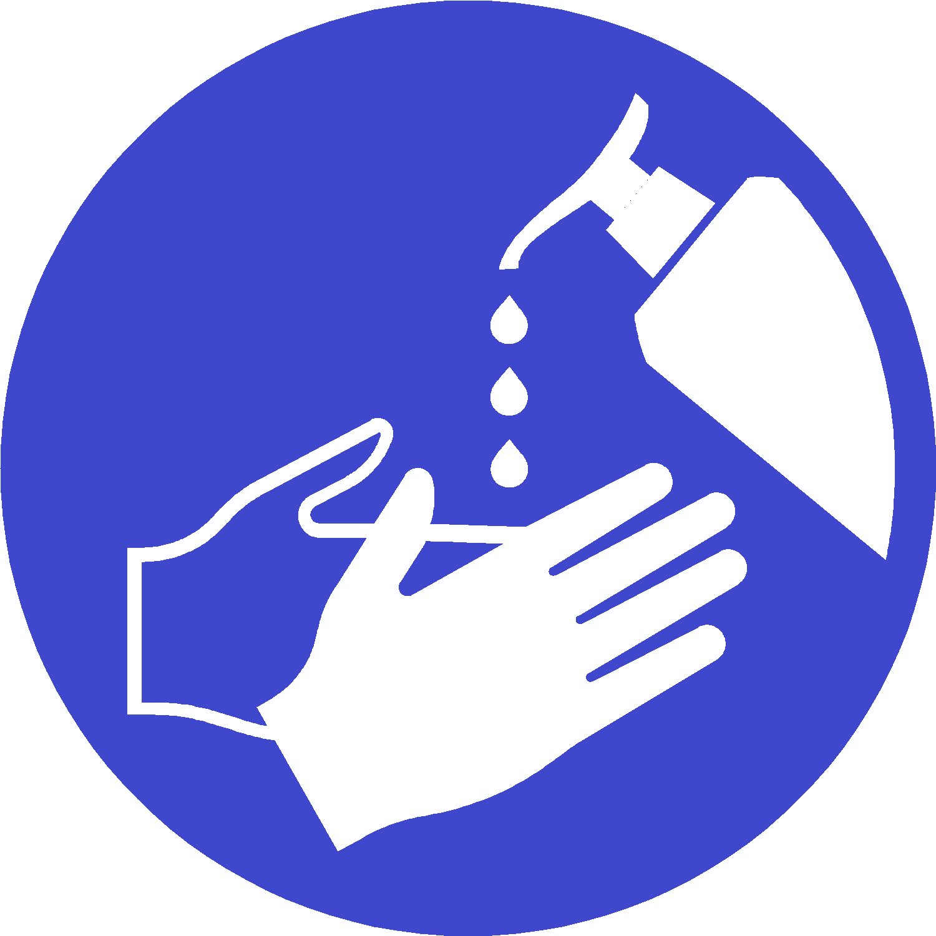

Covid-19:
Sanitise your hands

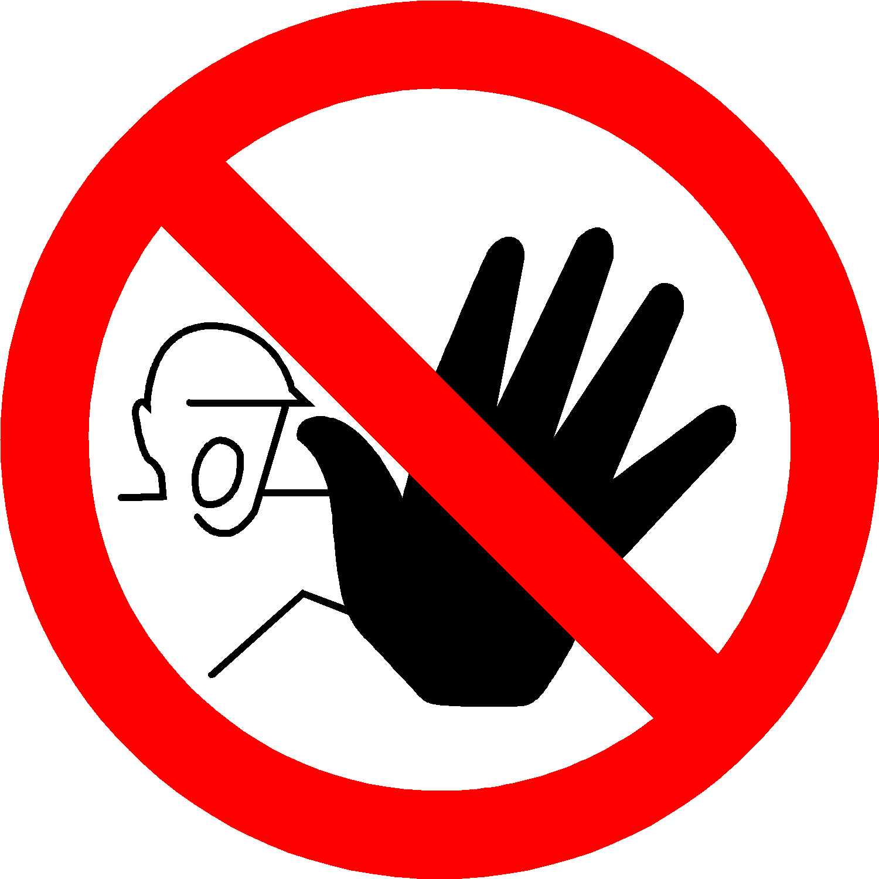




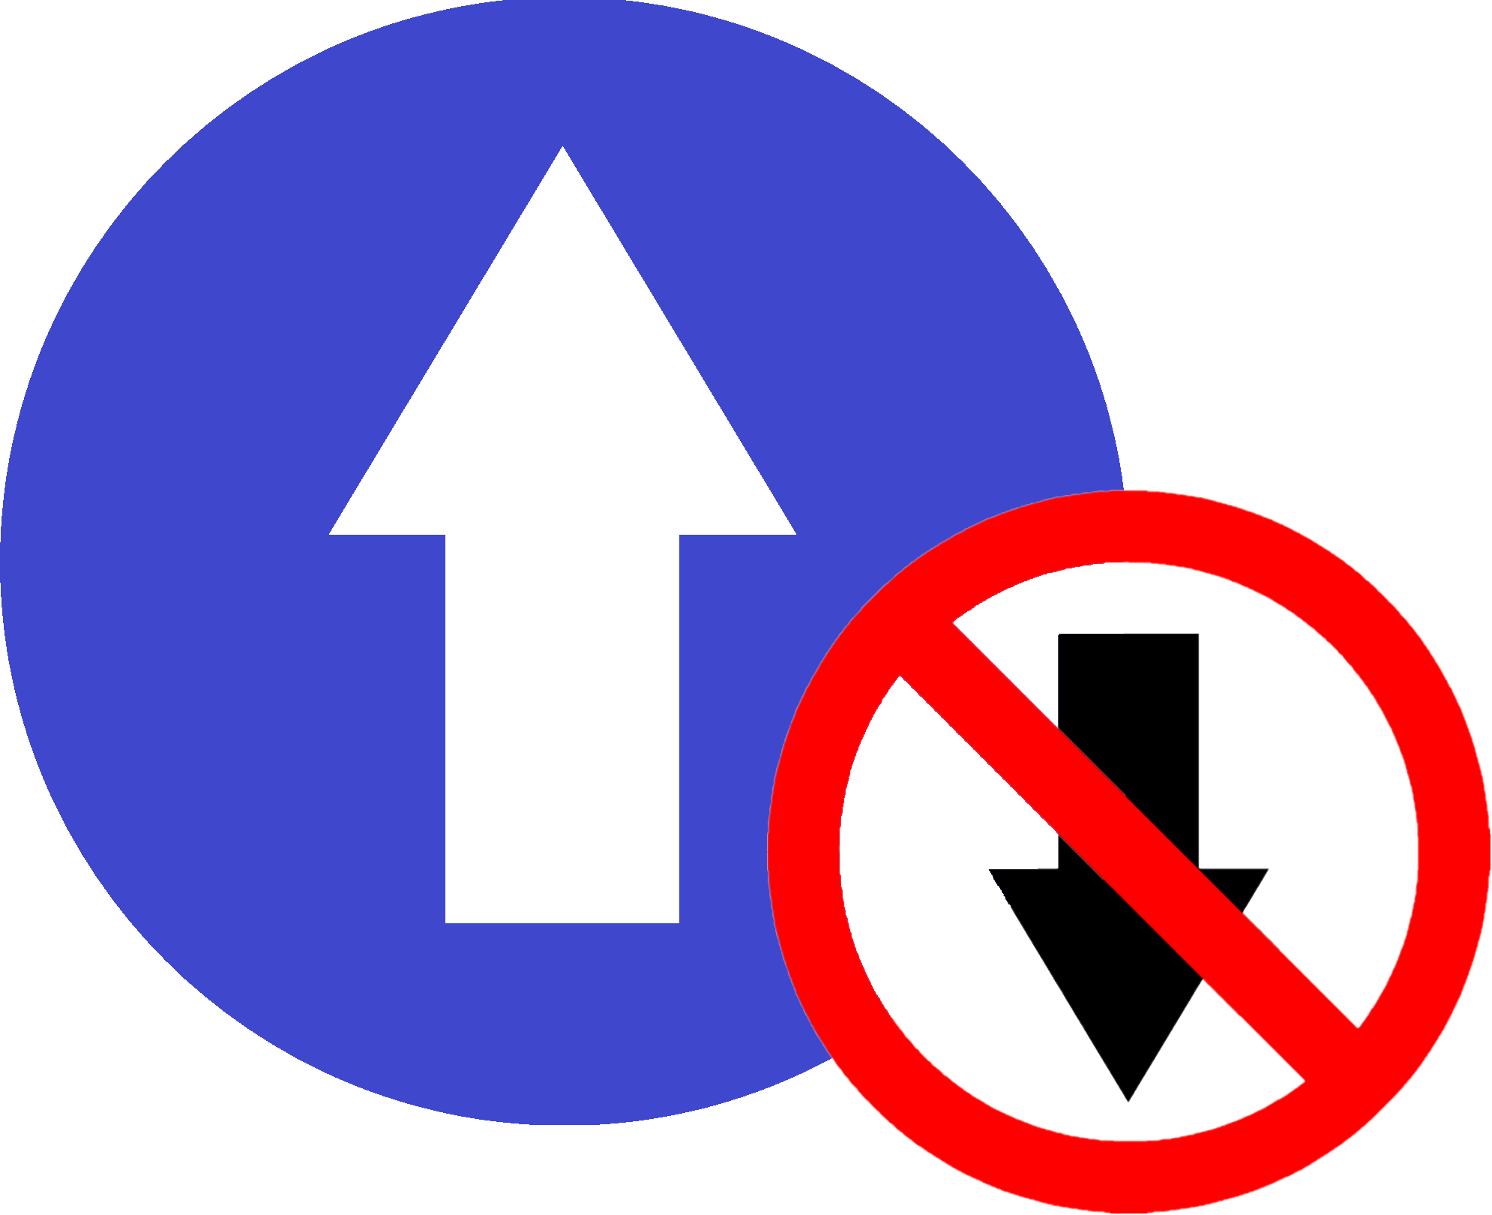

Covid-19:
One Way



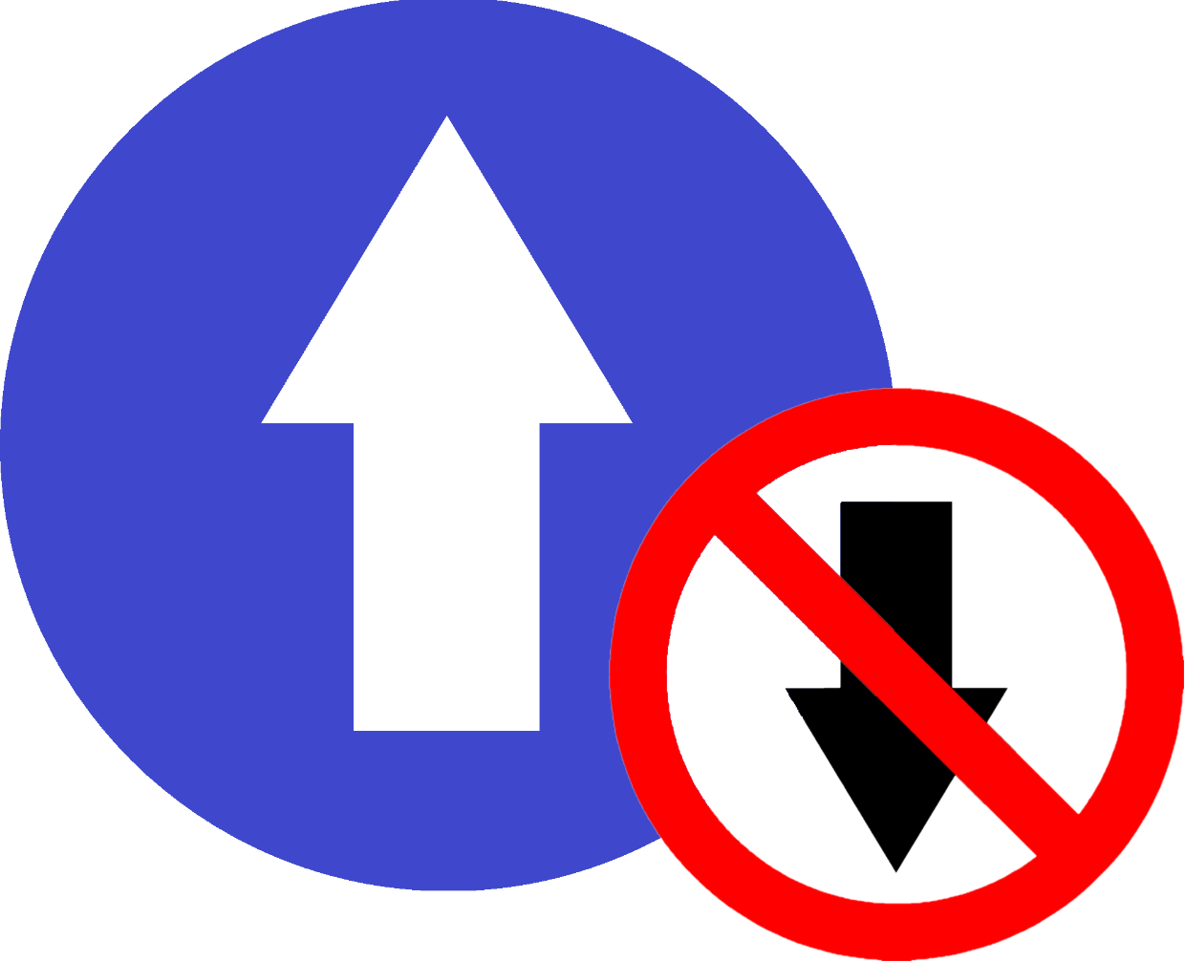

Covid-19:
One Way
Covid-19:
Follow One Way System



Covid-19:
Sanitise controls before and after use
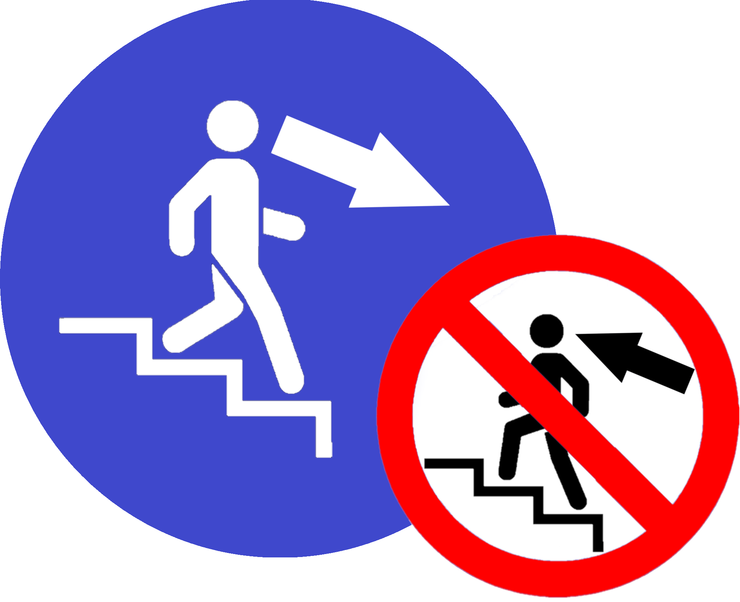
Covid-19:
DOWN stairs only
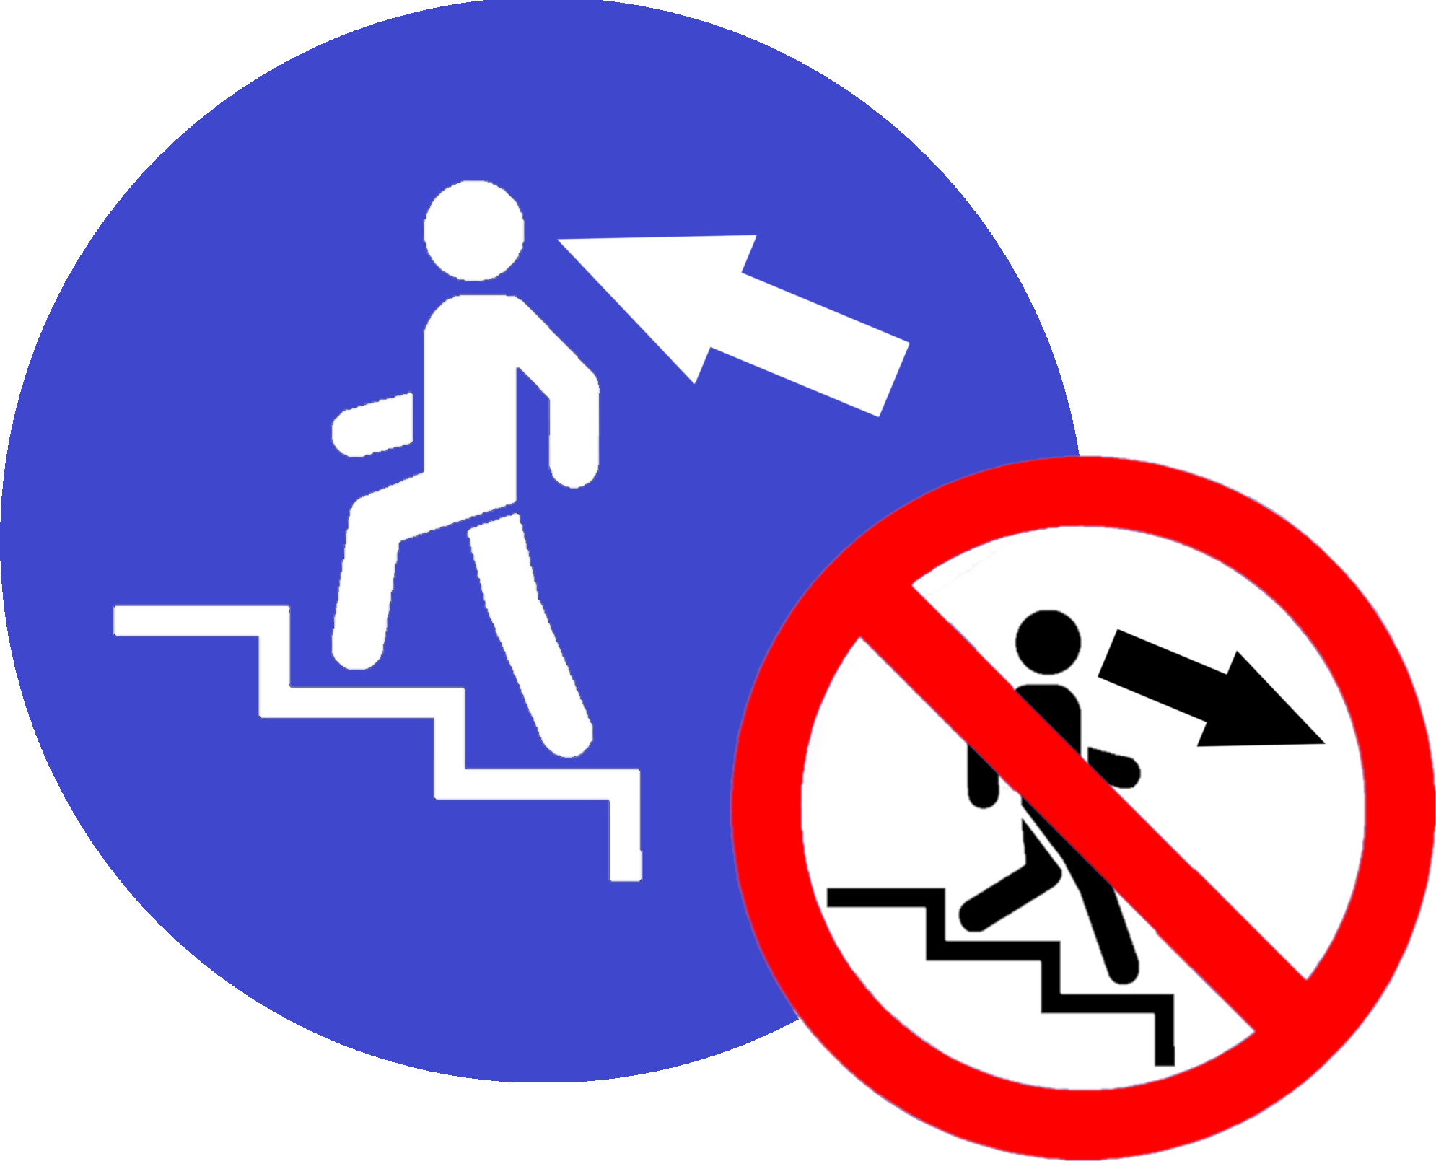
Covid-19:
UP stairs
only
Covid-19:
Restricted area

Max 5 persons
At any time

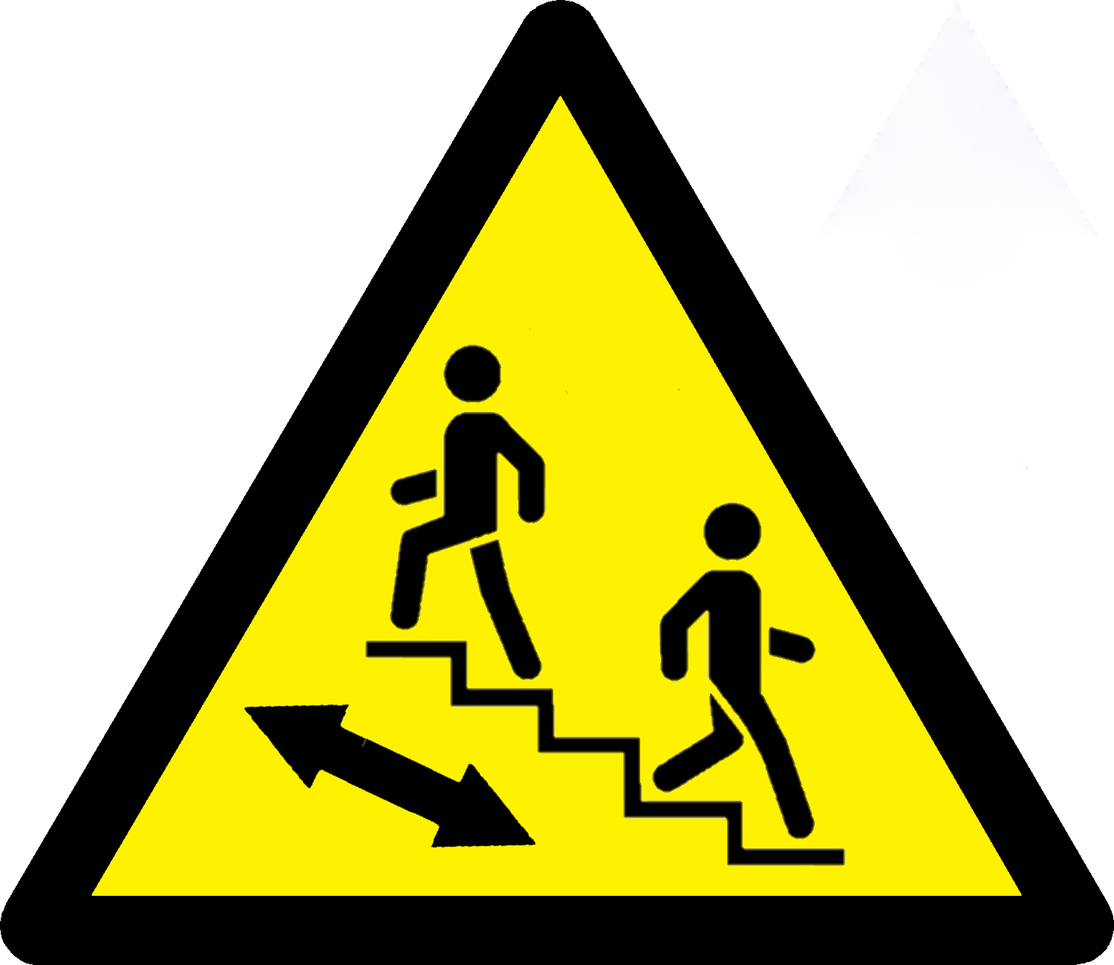
Covid-19:
BOTH WAYS
on stairs

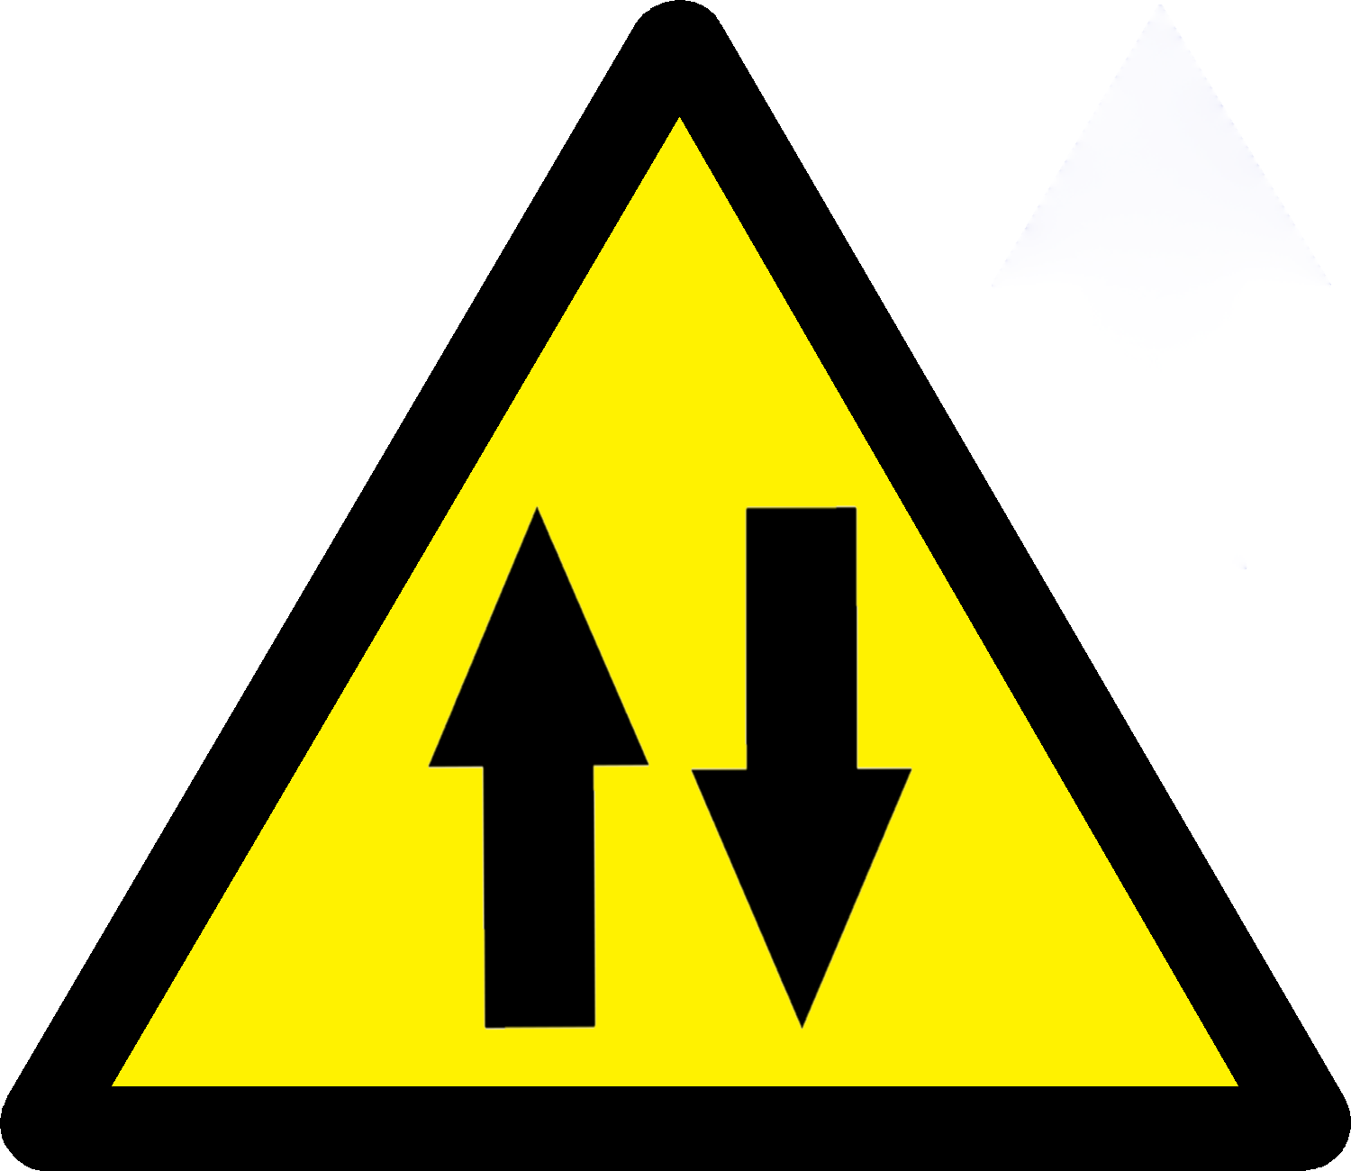

Covid-19:
Both Ways

