

Safety Newsletter


April 2025

In this issue you will find updates on:
- Safety Office General Updates | 2
- Safety Office “You Said, We Did”  - Safety Office Training Information | 4  5
- Workplace Safety | 6
- Helpdesk - Travel Safety | 9
- Biological Safety  - Chemical Safety | 10  10
- Radiation Safety | 13
- Occupational Health and Safety | 13
- Estates Statutory Compliance | 14

Safety Office General Updates

Comprehensive Technical Services now available on our homepage!

Electrical Appliance Testing (Formally PAT testing): working within the latest IET Code of Practice, electrical equipment is tested for safe operation with a Pass or Fail issued.
Face Fit Testing (Respiratory Protective Equipment): This service includes Quantitative Face Fit Testing and Face Fit Tester Training, ensuring accurate fitting of RPE and training for departments to upskill individuals to qualified testers.
For more information or to book a service, please visit our Safety Office homepage, click on the technical services button and visit the pages within the tile where details are provided.
Annual DSO Update Event: A Recap
On Tuesday, 25th March 2025, the Annual Departmental Safety Officers (DSO) Update event took place at the Faculty of Law. The event saw a turnout of 75 attendees, including members of the Safety Office Team and 3 additional attendees who joined on the day itself.
The event kicked off at 09:00 with registration and it was wonderful to see so many members of our safety community gathered in the atrium, greeting each other and engaging in lively conversation. Our Head of Safety Assurance and Auditing, Rory Feilen, did an excellent job of hosting the event and the day began with Stuart Males, our brand-new Deputy Director of Health and Safety Introducing himself to the DSOs, and setting the tone for the day’s presentations on the following key topics:
- Hot Topics from the Safety Office: A session led by the Safety Office Team, highlighting current issues such as problems with chemical supply chains, upcoming radon surveys and preparing for audit.
- Overview of protective gloves: Katy Atherton from Bunzl/Greenham provided valuable information on their extensive range of protective gloves offering multiple levels of protection from a wide range of hazards.


In our ongoing commitment to support departments, our range of technical services can now be easily accessed on our Safety Office homepage. Detailed information is provided about each service, along with a convenient click to book option.
Available services include:
Environmental Monitoring: assesses the working environment, identifying potential hazards with the following monitoring available, Mercury Vapour Monitoring, Noise Level and Hand Arm Vibration (HAVS) Monitoring.

Safety Office General Updates

- Managing multi-site departments: Sue Shaw-Hawkins from Clinical Neurosciences delivered a very entertaining presentation in which she shared her expertise on handling safety in departments spread across multiple locations.
- Managing Training Records: Greg Strachan, West Cambridge Technical Manager, discussed effective strategies for maintaining training records using UTBS.
- How to safely manage traffic on site: Joseph Mhishi from the Safety Office offered guidance on how to manage traffic safely across the university’s varied sites.
- Overview of Invida System: Andrew Rose from the Estates Division presented an overview of the new system designed to help the Estates Department and Facilities Managers streamline tasks involving asset management, compliance, and maintenance.
- Updates on roll-out of Safety Management System/Peregrine: Our Senior Business Partners Natalie Lazar-Adler and Richard Allen provided updates on the implementation of the new Travel Risk and Safety Hub Platforms being rolled out to all departments by the Safety Office.
The event also featured an impressive array of safety gloves on display, allowing attendees to explore a large variety of products first hand as well as gather lots of information about other available PPE.
The day concluded with a lively question time session, providing an opportunity for attendees to engage with the speakers and the Safety Office Team and provide more detailed information relevant to their roles, departments and site-specific issues.
We would like to extend our heartfelt thanks to all those DSOs who took time out of their busy schedules to attend this year’s event, helping to make it a success. For those who couldn’t make it, we would like to emphasise the importance of the annual DSO Update event as a key component of the training provided by the Safety Office, and we hope to see you next time.
This event is crucial for communicating changes and pertinent updates relevant to your role in line with the university’s health and safety policy. It also offers a great opportunity for networking and building our university safety community by giving us in the Safety Office a chance to meet you, and to work together with you to create a safer environment for all.
We are excited to confirm our next DSO networking event is scheduled for the 5th of June at the Post Doc Academy in Eddington. This event will feature members from each speciality subject area within the Safety Office, providing a valuable opportunity to discuss current key topics and share best practices.
Our networking events are smaller, less formal gatherings where we encourage DSOs to come along, meet your counterparts from other departments, and enjoy the benefits of working together as a safety community.

“You Said, We Did…”
This is where we will share some of the feedback and queries you have raised with us and what we have done in response. We hope you find this section helpful, and we encourage you, as always, to please continue to share your feedback with us so that we can support you and improve the service we provide. You can contact us using email: safety@admin.cam.ac.uk

You said you wanted more information about suitable gloves for working with physical hazards.

We brought in a supplier stall and glove PPE standards presentation at the recent DSO Update event. This was well received and many attendees at the event were seen visiting the stall and talking to the suppliers.



In the biological safety questionnaire sent to Biological Safety Officers (BSOs) last year you requested more specific training to support the BSO role.
In response to this we have organised for the Biosafety Practitioner Level 1 course to be offered in Cambridge later this year. Accredited by the Institute of Safety in Technology and Research (ISTR), it covers key principles and practices of Biosafety. Completion allows individuals to register as Level 1 Practitioners, adding to your professional development.
We also offer a variety of Biosafety training for BSOs, lab users and GM committee members, find all our courses on the Safety Office website Training page.
The BSO course series is not just for BSOs but open to all who have an interest in managing biosafety. Training will be a key focus in our upcoming annual BSO event on 20th of May, booking through UTBS is open!

You commented that it would be helpful if all safety training records could be accessible from one central place and viewed by all Departmental Safety Officers (DSOs), not just those working in the same department as the colleagues they need training information about.
All safety training recorded on UTBS can now be viewed across the University by all our DSOs.  This means a DSO in the Department of Chemistry will be able to check whether a visiting researcher has completed the University’s online Chemical Safety course. |  |  | All safety training recorded on UTBS can now be viewed across the University by all our DSOs.  So a DSO in the Department of Chemistry will be able to check whether a visiting researcher has completed the University’s online Chemical Safety course.
And if you are the visiting researcher, you no longer have to print out and share your training record from UTBS.  Instructions for DSOs in how to view safety training records can be found in the UoC_DSO SafetyNet team in the file folder DSO update event March 2025. |  |  |  |  | And if you are the visiting researcher, you no longer have to print out and share your training record from UTBS.  Instructions for DSOs in how to view safety training records can be found in the UoC_DSO SafetyNet team in the file folder DSO update event March 2025.

Lone working training
 | Have you ever considered if you would be classed as a lone worker? Lone working means working by yourself without any close or direct supervision. You become a lone worker when you can’t be seen or heard by another person when you’re at work.  Lone working can occur during normal working hours at an isolated location, or outside normal working hours, on weekends, bank holidays or when the Department or Institution is closed.  If you are out of eyesight and out of earshot, you have nobody to help or support you if things go wrong.  The Safety Office Lone Working online course looks at how lone working can be managed safety in the University. It explores what is meant by the term “lone working”, how it can impact your safety and what regulations guide lone working within the University, then steps through the process of creating a risk assessment for lone working.  The online course takes approximately 40 minutes to complete. Book your place on UTBS.  The Lone Working course is also available on request as an in-person session of approximately 30 minutes, usually delivered along with manual handling or working at height courses. Please contact the Safety Office using email safety@admin.cam.ac.uk , if you would like to arrange an in-person session in your institution.

New online course: Introduction to working safely with cryogens
 | Our new Introduction to working safely with cryogens is a 50-minute online course, suitable for all staff and students working with cryogens and associated equipment in the laboratory.  The course covers key aspects of safe handling
and use, including the physical properties and hazards associated with cryogens and associated hazards, working with different types of cryogenic vessel, selecting appropriate safety equipment, PPE and spaces to work in, how to safely transport cryogens, how to dispose of them, and what to do in the event of a spill or leak.
You can find a full list of objectives and book a place on the course on UTBS.
UTBS UPDATE
The University Training Booking System (UTBS) is ready to receive training courses that are run locally from departments, please endeavour to put these onto the system so we can capture the training centrally. This will give the Safety Office knowledge in what is going on in departments regarding training and this then allows us to better target areas of need or offer help or advice.

Safety Office Training Information

With regards to access to Safety Office courses, these can be found on the first page of the UTBS under drop boxes along the top with areas such as Courses, Themes, Programmes.
You can also access the search box which gives links to training that’s delivered face to face, online or virtual, this training will be listed as scheduled.
For unscheduled training there should be a link under the search box, this will direct you to the trainer and the link to their email, they can then offer more details for you.
Each training course headline should have a downward arrow on the right-hand side of the headline this when clicked provides more information about the course.
Once the course information has been obtained, you may be able to find information on the venue under the venue banner towards the top of the screen, this can give details of the room, which department it belongs and a map to show where it is.

Safety Office Training Information


Anaphylactic Auto-injector Adrenaline pens in the workplace
If you are a University first aider or avid watcher of BBC’s Dragon’s Den, you may be aware of a company trying to encourage generic auto-injector adrenaline pens into the workplace to deal with allergic reactions to food resulting in the individual going into anaphylactic shock, in much the same way as Defibrillators are present to deal with those suffering from Sudden Cardiac Arrest.

Workplace Safety

The University Working Group for First Aid have reviewed these in consultation with Dr Geraldine Martell, Consultant Occupational Health Physician, and found the advertising around these kits is quite misleading. These kits contain prescription medication and can only be acquired by companies that have access to an occupational health department where a physician will sign to take responsibility of the drugs contained within. We are predominately an adult institution, and individuals with allergies requiring adrenaline auto-injectors should continue to carry and be responsible for their own injectors pens with the assistance of a first aider to administer if required.
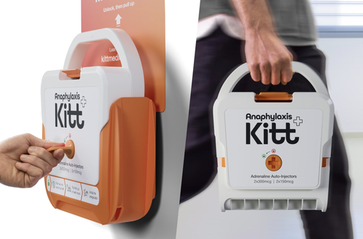

Workplace Safety

Should individual departments that have visits from children and serve food, such as our museum spaces feel a generic auto-injector is required, Dr Martell has requested a specific risk assessment to review before any decision can be made, along with additional information on the training of individuals who will be responsible for delivering the injections should the need arise.

For more details on this please contact Andrea Eccles in the Safety Office.
Reminder: Statutory Inspections of lifting trollies/platforms
Do you have a lifting trolley or a high lift pallet truck that can raise the forks or platform more than 30cm high? If so, these need to be inspected annually to comply with legislation and fall under the Lifting Operations and Lifting Equipment Regulations (LOLER).
It has been brought to the attention of the Safety Office that several departments are operating such items without this statutory inspection being completed and the item has not been registered for these to be undertaken. These inspections are carried out by British Engineering Service Group (BES), the University nominated competent engineers, it is a centrally funded contract and will not cost your department anything to register these items on the system and have them inspected. (Please note: if the item does not raise above 30cm, it will not require a statutory inspection, but it would still need to comply with PUWER. For further information go to HSD088P Provision and Use of Work Equipment Regulations (PUWER)).
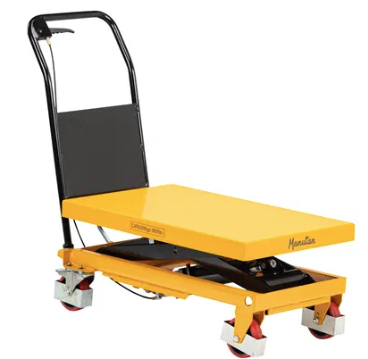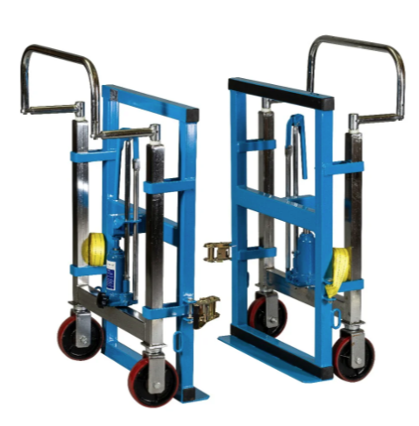
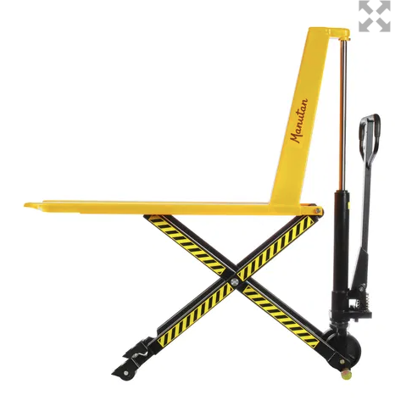

The images shown here are examples that would require inspection and must be registered with BES Group.

To register items please contact nicholas.langley@besgroup.com . He will need to know the

exact location of the item, the department who owns it and the nominated individual who they will need to contact to arrange the inspection. Departments must have a nominated person managing inspections of assets falling under these regulations and this person must be known to the Safety Office. Make sure to inform the Safety Office of any changes and contact details for these individuals and keep your asset list up to date, notifying of additions and deletions to the list.
If the item has not been inspected in line with current legislation, or the inspection date has lapsed, it MUST NOT be used because it is non-compliant and as such, the University is NOT INSURED TO OPERATE IT. Uninspected and poorly maintained items can also lead to serious injuries or worse. Ensure equipment is available/accessible for inspection on the arranged date.
For further assistance, please contact Sara Thompson (st293@cam.ac.uk ) or Andrea Eccles (abe24@cam.ac.uk).

Reminder: Statutory inspections of ladders and kick stools
Do you have ladders and kick stools? Are you trained in their use and how to inspect them?
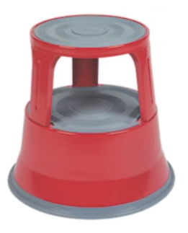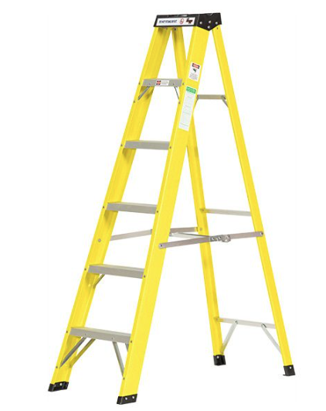
Why Is Ladder Inspection Training Important?
To prevent accidents from height, employers have a legal duty ensuring work is properly planned, supervised and carried out by competent employees. They must also ensure the equipment they use is fit for purpose and suitably maintained. Regular ladder inspection must be carried out routinely to check for damage and deterioration. The University provides training: Working at Height: Safe Use of Ladders and Stepladders.
Anyone attending this course would be deemed competent to carry out ladder inspections on behalf of the University. Records of such inspections should be kept.
For further information or to book onto the course please contact Neil.Stanford@admin.cam.ac.uk .
Workplace Safety

Falls from a ladder can happen at any time. And the results can be disastrous. Accidents involving ladders can result in life-changing injuries for those involved and significant time off work, as well as extensive costs for the University.
The Work at Height Regulations 2005 states that all ladders must be inspected at time periods set by the environment where the ladder is used. These inspections should also include kick stools.

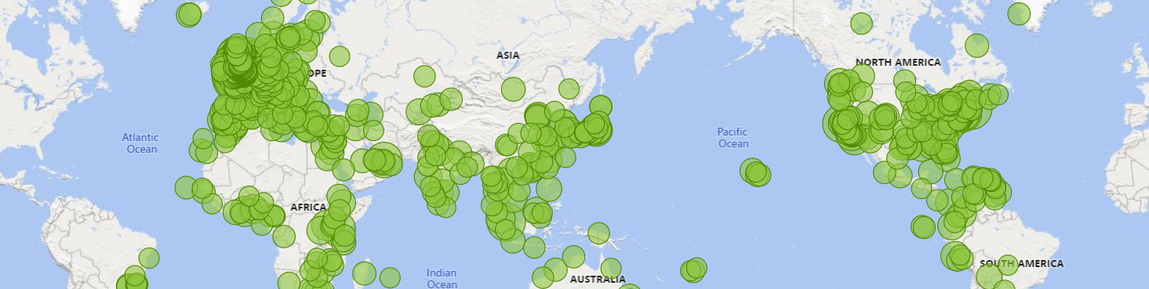
Peregrine Foresight and Travel Insurance
We have rolled out Peregrine Foresight to 90 institutions in the University and are working to help the final handful of departments onboard.
Travel insurance is free to both staff and students travelling for University business. The link with travel insurance is live, which means applying for University travel insurance now occurs within the Peregrine Foresight risk assessment process. For more information about how this works please visit: Recent changes to automatically link Foresight to University travel insurance | Safeguarding Work Away.
Travellers have a copy of their insurance cover note within their Peregrine Foresight risk assessment and are encouraged to download a copy to carry with them while travelling.
It is important travellers understand that although University travel insurance will cover up to one week’s incidental holiday either side of a work trip, it does not provide cover for any high-risk leisure activities such as skiing, diving and horse-riding which are undertaken during leisure time within the work trip or as part of any incidental holiday. Travellers will need to arrange cover if they plan to take part in such activities during leisure time on their trip.
Trips to high-risk locations (Travel Insurance | Insurance) will still need to be referred to the insurers for approval outside of the Peregrine Platform.
Thanks to colleagues who attended recent workshops, new trip type templates are now available for:
Laboratory visits – staff and student versions
Undergraduate Year Abroad – for students on Tripos programmes with a Year Abroad, including Modern and Medieval Languages, Asian and Middle Eastern Studies and Law.
Clinical Medical Students Summer Elective – for medical students undertaking elective placements in the summer vacation.
Development work on the Group trip templates is ongoing, as this has proved a more complex piece of work than anticipated. We will update you when this is completed.
In addition to the information for travellers and Approvers on the website, we have also prepared a one-page Top Tips guide for Approvers.
Revisions to the core document Guidance on Managing Risks from Travel, Fieldwork and Work Away have been approved by Health & Safety Executive Committee and will appear on the Safeguarding website shortly. These revisions update arrangements around our Peregrine Foresight platform.
Please continue to contact the International Support Helpdesk for help with using Peregrine Foresight, or any questions or feedback on using the system: internationalsupport@admin.cam.ac.uk

Helpdesk – Travel Safety

Biological Safety


Updates for Departments Working Under the University HTA (Human Tissues Act) Research licence (12196)
We have introduced several improvements to our processes in response to our HTA inspection last year, these include:
- Changes to reporting of human tissue adverse events and incidents
All adverse events, incidents and near misses relating to human material must be reported as soon as possible. Examples include specimen loss, missing/incorrect documentation, security breach, abnormalities in storage temperatures or inappropriate disposal. We have updated the HTA Quality Manual with SOP 9 (adverse event and incident reporting for relevant material) detailing instructions on how to report these via AssessNET using new ‘HTA Administration’ centres for each department. Please update any local departmental procedures to reflect these changes.
- HTA compliance risk assessment
The new risk assessment template should outline all risks to human material and contingency measures in place to prevent adverse events and incidents from occurring. Please can all Persons Designated (PD) complete the new HTA compliance risk assessment by the end of April so these can be sent back to the HTA inspector.
Thank you to all our PDs for providing information and supporting these new changes. For any questions or advice on HTA matters please contact hta@admin.cam.ac.uk .


Ordering and Delivery of Chemicals
The department of Materials Science and Metallurgy has had two incidents with hazardous chemicals not being correctly labelled on arrival. In both cases the chemicals had previously been ordered by the department from standard UK chemical suppliers without any issues, however, due to worldwide supply issues these were no longer available. The researchers found new suppliers and followed the standard procedures and provided all requested information to procurement to set them up in the CUFS system.
The first order arrived and was not immediately collected by the researchers which led to further investigation. The package was labelled as being calcium carbonate which is
Chemical Safety

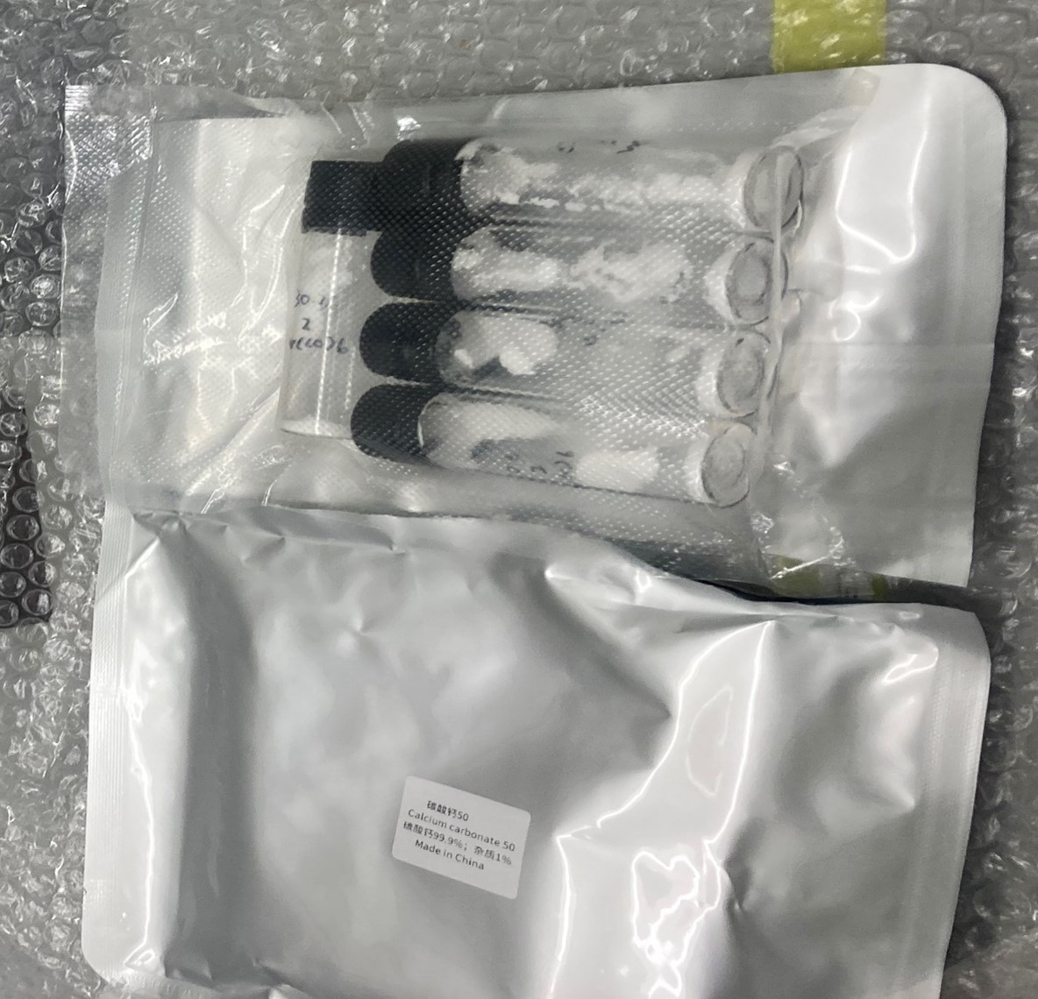
The internal bottles were also labelled as Methyl silicone oil. The supplier later stated openly in an email that the samples has purposely been mislabelled to avoid customs scrutiny as the customer had not specified how the goods should be labelled! In this case it was a Chinese company, and the chemical was shipped direct from China.
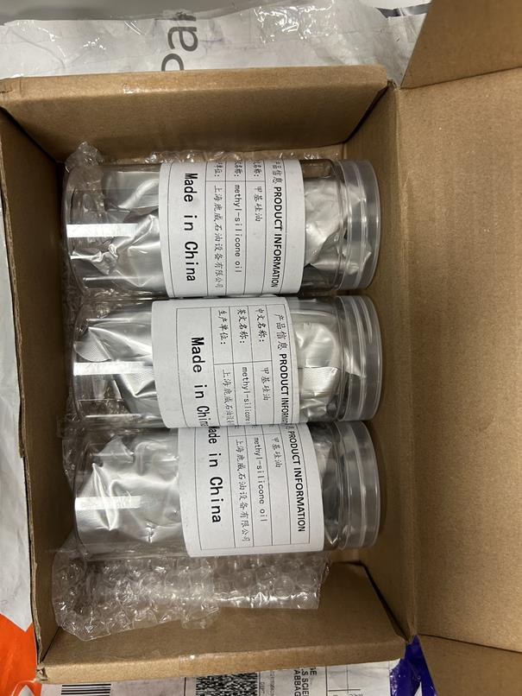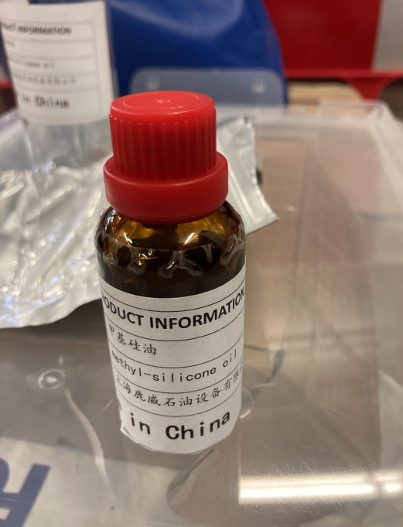
The incidents have been reported to the University’s Dangerous Goods Safety Advisor (DGSA) who has said that this is a very common occurrence with goods shipped from China.
Ideally, all chemicals should only be purchased from reputable suppliers, where not possible extra care should be taken. It is assumed that all suppliers will follow international shipping rules but that is often not the case. Anyone receiving chemicals from any supplier should always take care when opening packages in case of leakage in transit.
Please report any incidences of this nature on AssessNet to ensure we can log them and report them to the DGSA.

non-hazardous but no orders for this material could be found. From the order number it was found to be Tungsten hexacarbonyl which is a toxic chemical. The packaging provided minimal protection, and the vacuum-packed vials inside had handwritten illegible labelling.
The company was a UK company, but the order was shipped directly from China. The registered address for the UK company was traced to a block of flats in London.
The second order was labelled as non-hazardous Methyl Silicone oil, but order was for Poly(tetrahydrofuran) which is an irritant.

Chemical Safety

These incidents could have cause harm to anyone throughout the shipping process, so the suppliers have been removed from the system to prevent any further orders being placed and the chemicals have been disposed of due to it being impossible to determine if they were the required chemicals.

Diphoterine

What is it?
Diphoterine is a commercial decontamination solution that can be used instead of water as an emergency rinse for a range of hazardous chemicals splashed on the skin or eyes. While the quality of evidence supporting Diphoterine use is mixed, the British Burns Association recommends the use of ‘amphoteric solutions’ (of which Diphoterine is the only one commercially available) for chemical burn first aid.

Current Safety Office position:
The First Aid Working Group has confirmed that departments are free to use Diphoterine in accordance with the manufacturer’s guidance instead of washing with copious water. This excludes chemical splashes/burns which require more specialised treatment as described in Safety Data Sheets or specific University guidance, for example hydrofluoric acid burns.

Further information:
Regardless of whether Diphoterine is more effective than washing with copious water, on balance it does not appear to be more harmful. As well as physically washing the chemical off affected tissue, Diphoterine might provide additional aid by neutralising acids or alkalis without overheating, or by safely capturing several other types of hazardous chemical. The manufacturer states that the rinse may be able to draw some contaminating chemicals out of affected tissue. Departmental Safety Officers should be aware that as first aid supplies, bottles of Diphoterine require replacement after 2 years. Do not attempt to use other chemicals to neutralise general acid or alkali splashes on the skin or eyes.


Chemical Safety


Radon monitoring at the University: what you need to know

Radon is a naturally occurring, colourless, odourless and radioactive gas that can accumulate in buildings. While long-term exposure is a known health risk, the University is not in a ‘Radon Affected Area’, meaning the overall risk is low. However, as required by the Health and Safety Executive (HSE), the University must conduct radon surveys every ten years for ‘occupied’ underground spaces – basement areas used for more than 50 hours per year. These surveys help to ensure that radon levels remain within acceptable limits.

The Radiation Protection Team (RP Team), based in the Safety Office, will contact all departments to gather information on underground spaces. If monitoring is required, the RP Team will oversee the process. Departments must follow the RP Team’s instructions and implement any recommended actions to maintain a safe environment. If your department is contacted regarding a survey, please cooperate fully to ensure smooth and efficient monitoring. For any questions or further guidance, contact the RP Team at the Safety Office, our details can be found on the Safety Office website under Radiation Safety.

Nuclear Safeguards Regulations (preventing the proliferation of certain radioactive materials for “non-peaceful purposes”):
To ensure that the University is complying with these regulations, Departmental Safety Officers should continue to check for any stocks of uranium and thorium that have not been previously declared to the Safety Office.
Please contact radiation-protection@admin.cam.ac.uk if any items are found, and if there are any plans for acquisitions (including transfers) or disposals.

Radiation Safety


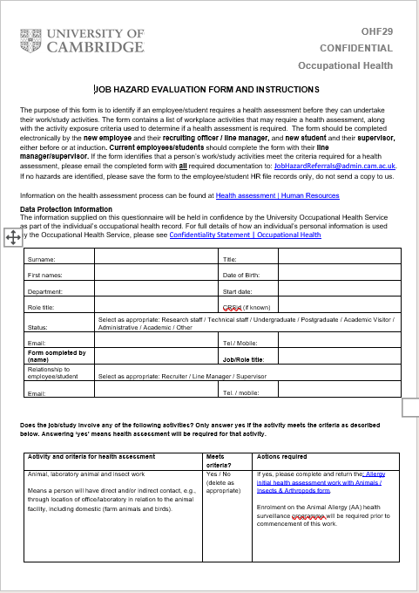
Change to Job Hazard Evaluation form and process (OHF29)

Occupational Health

There has been a change made to the Job Hazard Evaluation form and process (OHF29). The form and guidance document have been merged to make the process easier for those completing it. All new forms MUST now be sent to JobHazardReferrals@admin.cam.ac.uk for initial assessment.


The new form can be found on the Occupational Health Job Hazard Evaluation form page. Please delete all local copies of the previous form and guidance and only ever download the form from the Occupational Health Job Hazard and Evaluation form page.
Occupational Health


Estates Statutory Compliance
Statutory Compliance Team Update & New Appointment
The Statutory Compliance Team has recently undergone key changes that strengthen their position within the organisation and enhance their ability to support compliance across the University.
The team has moved out of Asset Management and has now joined forces with the Estate Division’s Health & Safety Team. This realignment allows for greater independence and impartiality, reinforcing their central role in setting and maintaining standards for building-level and asset-specific compliance.
While the structure may have changed, the team's focus remains on compliance, risk reduction, and providing a robust consultative service to the Estate Division, the wider University, and our supply chain partners.
They continue to play a pivotal role in ongoing asset digitisation and service delivery projects, contributing to asset verification, maintenance programme development, and supplier onboarding.
The compliance leadership team is also actively improving the mechanisms for compliance reporting. These developments are fully aligned with the rollout of the new Invida CAFM system and, as implementation progresses, will bring greater transparency and visibility of our statutory compliance levels across the estate.
Finally, we’re pleased to welcome Louise Massey to the team as our new Asbestos Manager. Louise brings extensive experience in asbestos management, legislative and working practice and will be instrumental in advancing our compliance strategy in this area. Louise’s previous roles as a contracts manager and key account manager for major retailers, Councils and NHS Trusts has provided her with a wealth of compliance-based knowledge and the necessary skills required for team leadership, account profitability and project management.
Please join us in welcoming Louise and supporting the team as they continue to evolve and strengthen their services across the University.

