

Safety Newsletter


July 2025

In this issue you will find:
- Safety Office General Updates | 2
- Safety Office “You Said, We Did”  - Safety Office Training Information | 5  5
- Helpdesk Updates | 8
- Radiation Protection | 8
- Workplace Safety  - Biological Safety | 9  11

Safety Office General Updates

Our website documents are migrating to our SharePoint Safety Hub

Most departments have now received rollout sessions introducing our new SharePoint site, Safety Hub. While departmental pages are already live and in use, work has begun to develop the Safety Library section with our end users in mind. We have received your feedback from our website survey, and we are developing the functions within the Hub so that you can more efficiently search and browse our library pages and documentation.

Our webpages for our safety sections will therefore migrate to live within our SharePoint Safety Library. To make this a smooth transition we will place redirects on our website so that you can find the co-responding pages. The migration will happen over time, and we will provide you with updates ahead of moving our information.

This migration project may cause some links to break within departmental information, where links to our documents are hosted directly by our Drupal site. Placing redirects on our webpages will reduce the volume of broken links incurred by the move but we will provide updates ahead of when we plan to move pages and documents.

If you have concerns about this or would like more information, please do get in touch by emailing Safety@admin.cam.ac.uk .

A timeline will soon be available on our website, where you can find out when we plan to move documents well in advance of any changes taking place.

Updated training matrix for safety role holders
We recently updated our training matrix to include new courses that have now been published and we have simplified the layout for easier navigation. Please use this to guide your own training or as a starting point to create your own local training plan.
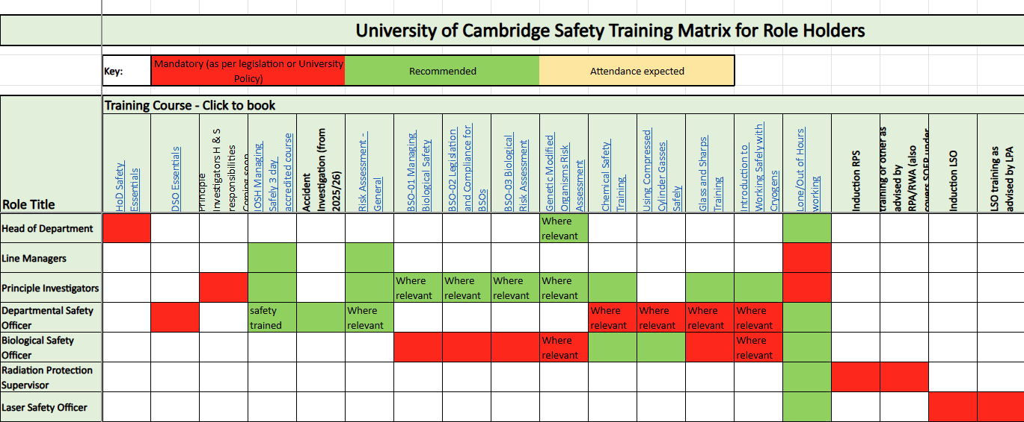

Safety Hub
We can help you develop your Department Safety Hub page. Some teams already have well developed Health and Safety information sharing in place, but if you would like to develop your team communication using your new Hub Dept page please get in touch and we will help. Request a ‘safety hub’ meeting here.
For support, questions or to update role holder information please contact:
- HSD Safety safety@admin.cam.ac.uk
- Richard Allen rea52@cam.ac.uk
How can the Safety Hazard and Risk Register help you?
The Hazard and Risk Register (HRR) was rolled out to most departments in 2024 as part of the Safety Hub. During this time, we shared with you the potential benefits: for you as departments; for the Safety Office supporting departments; and for the University focussed safety strategy. We’re therefore keen to share with you real examples of these benefits playing out. The Faculty of Mathematics completed their Hazard and Risk Register in November, driven by James Wilcock their new Department Safety Officer (DSO).

Working through each hazard, James consulted relevant members of the Faculty and documented both strengths and areas for potential improvement in their safety management system. He identified that the process for ensuring staff had completed Display Screen Equipment (DSE) assessments for their workstations was not robust and that not everyone had completed these. He was able to use the HRR to effectively prompt discussion in the Faculty health and safety committee. Both Heads of Department attended the committee and were quick to support this as a departmental initiative.

Though the roll out of Cardinus was coming soon, their priority for action spurred them on to develop a new process in which new starters would all receive assessment forms, assigned role holders would monitor for completion and escalate concerns to nominated competent DSE assessors.

They now have follow-on actions to build resilience of the process by documenting these new arrangements – one possibility is on their Safety Hub department arrangement pages – and to embed awareness of ergonomic issues into their induction and training programmes.

They plan to continue consultation on the HRR across the department, using it as a prompt and means to review many aspects of their safety management system, and for it to become a regular part of their health and safety committee discussions.

Safety Office General Updates

Chemical and Infectious Waste
We are still going through a period of change for our waste contractors and waste routes. In order to better support departments, Fiona Berry (Contract and Supplier Manager – Procurement Services) has setup Teams Chat where Stakeholders can field questions and suggestions around the chemical and biological waste arrangements with Tradebe and Sharpsmart. If you are involved in consigning waste or advising on the correct routes, this group may be of interest to you
Please contact the Safety Office to be added to the chat,
email: Safety@admin.cam.ac.uk.

Safety Office General Updates

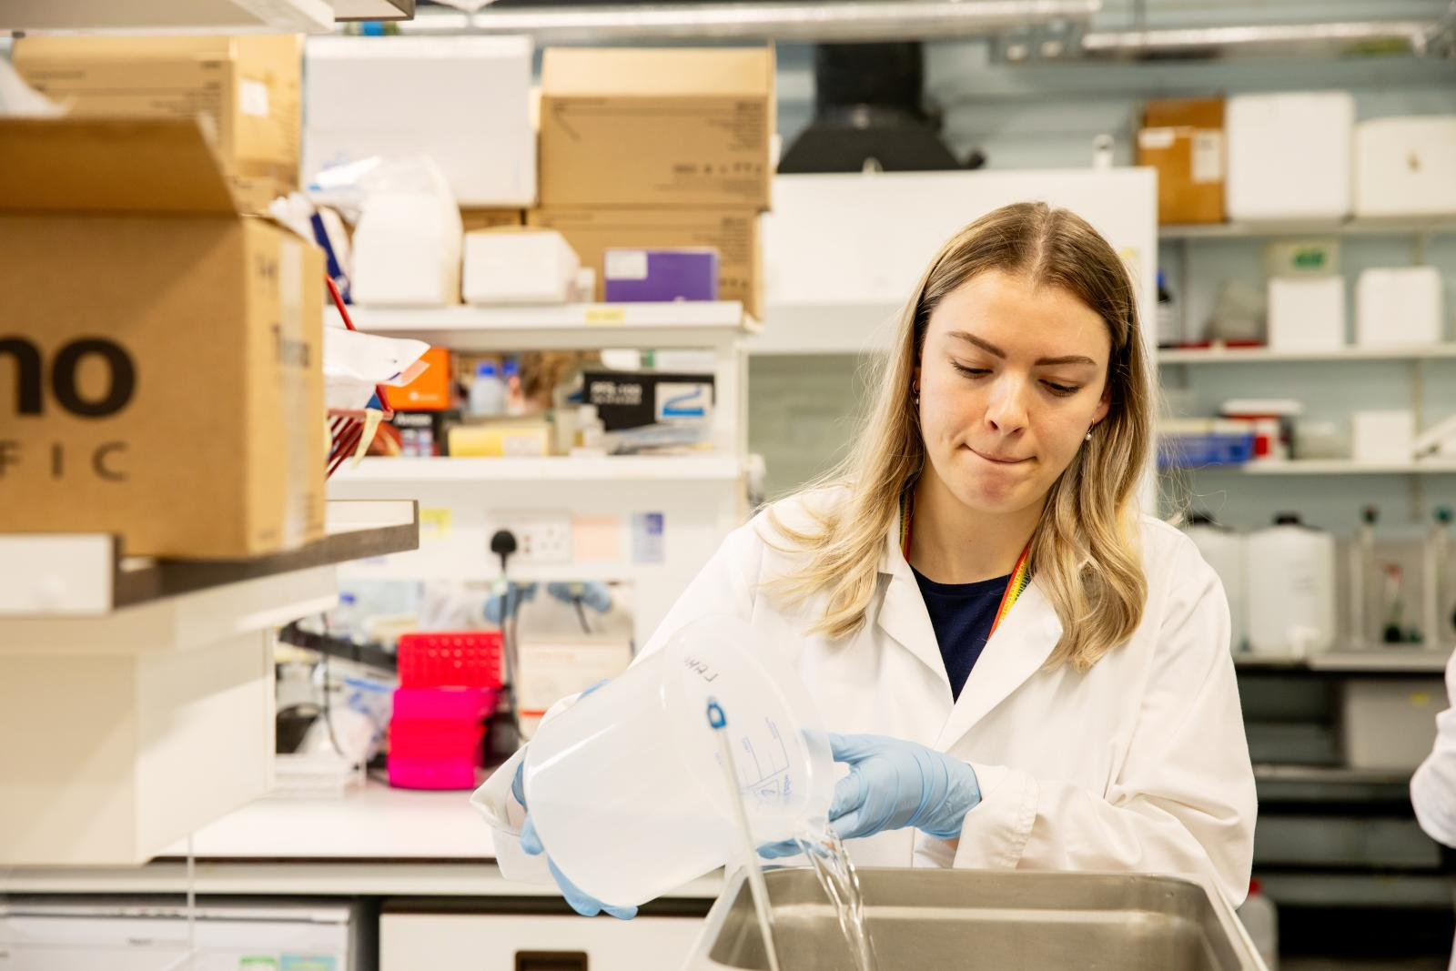

“You Said, We Did…”

We Listened – Training Enquiries Made Easier
We heard your feedback that finding how to enquire about our training courses on the website was not as straightforward as it should be. Previously, the contact email was tucked away in a link at the bottom of the training overview page and easy to miss.
We’ve now made it simpler. You can now find the training enquiries email directly under our Contact Us tab, making it much easier to get in touch with us about any of our training courses.
Want to reach us now? Contact: safety.training@admin.cam.ac.uk
Thank you for helping us improve your experience!

We’re revamping the newsletter for you!
We recently sent out a survey to DSOs to get their feedback on the Safety Newsletter. Thank you to all those who took part in the survey. We are grateful for your input.
In response to your feedback, we are giving the Safety Newsletter a makeover! Look out for the updated Safety Newsletter coming in the new academic year with new layout, new content and updated branding.

Risk Assessment Training
We run courses at Greenwich House for Risk Assessment training but if you have 12 or more people wanting to have Risk Assessment training, we can also come to you. All we need is a room with audio visual equipment that can display a PowerPoint presentation. The course has a duration of 2 ½ hours, with a tea/coffee break halfway through, and involves 2 workshops. Drop us a message at st293@cam.ac.uk if you are interested.

Safety Office Training Information
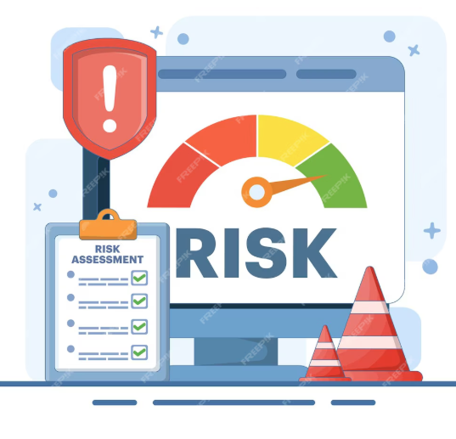

Asbestos Awareness Training - Message from the Estates Division
Asbestos Awareness training must be completed and is mandatory for anyone who is likely to disturb the fabric of the building during routine maintenance or repairs, any contracting officer who instructs others to carry out such work, and anyone responsible for managing a building.
The following course dates have been scheduled.
- Mon 1st September
- Mon 6th October
- Mon 3rd November
- Mon 1st December
All training sessions will be held in the Jaffna Meeting Room at Greenwich House from 0900 – 1230.
To book a place contact AsbestosManagement@admin.cam.ac.uk . These dates will also be published on the training page shortly.

Online course refresh: Health and safety induction for staff
 | Our new Online: Health and Safety Induction Training (for staff) course was launched for new starters in June. The refreshed course has sections on how the University supports your health and safety, thinking about your workstation, what to do in an emergency and how to stay safe in Cambridge and beyond.
It is important to us all that staff feel they have a vital role to play in the University health and safety culture and actively engage with safety practices. By the end of this course new starters will be able to:
- Describe the University offices, departmental roles and other resources supporting their…



…safety at work
- Report health and safety concerns and ask questions to an appropriate person
- Identify next steps, including where to find other safety training courses
- Share how they plan to contribute to workplace safety
All new starters are linked to the course in their induction, but anyone wanting a refresh can book a place on the course on UTBS.
Chemical Safety Training
We are currently reworking the Chemical Safety Training; the updated version will be available for the new Academic year.
The Hydrofluoric Acid and Compressed Gas Safety training courses are also in the pipeline for review. Please do send us any feedback on the current courses that might help us improve them, email us at chemicalsafety@admin.cam.ac.uk .

Upcoming Safety Training
There are still places on the following safety related training courses:
August
- Wed 6th - Departmental Fire Safety Manager Training
- Thurs 7th - Peregrine Foresight Approver Training
September
- Mon 1st - Asbestos Awareness Training
- Wed 3rd - Peregrine Foresight Approver Training
- Wed 3rd - Departmental Fire Safety Manager Refresher Training
- Fri 5th – Fire Safety Awareness Training
- Mon 8th - Fire Safety Awareness Training for Embedded Departments at Addenbrooke's Hospital
- Wed 10th – Risk Assessment
- Wed 24th - Fire Safety Awareness Training for Embedded Departments at Addenbrooke's Hospital

Click the links for more details or to book a place through UTBS!

Safety Office Training Information



Helpdesk Updates


Health Information for Academic Visitors from overseas
If your Department welcomes Academic Visitors from overseas, please include links to information about obtaining healthcare whilst in the UK in any joining instructions you provide.
The NHS webpage How to access NHS services in England if you are visiting from abroad - NHS is the key source to link to. It is important that visitors staying for more than three months register with a GP soon after they arrive so that they can seek medical attention if they become unwell at any point (How to register with a GP surgery - NHS). GP Treatment is free of charge to international visitors.

Helpdesk Operations
Gillian Weale is leaving the University on 23 July to take a career break. Karl Wilson will be overseeing the Helpdesk and taking the lead on Communicable Diseases management after Gillian’s departure. Natalie Lazar Adler will be leading on the further development of Peregrine Foresight and support for safe travel.
Please continue to contact the Helpdesk as before via:
- cd-helpdesk@admin.cam.ac.uk for Communicable Diseases enquiries.
- internationalsupport@admin.cam.ac.uk for travel safety and Peregrine Foresight support.

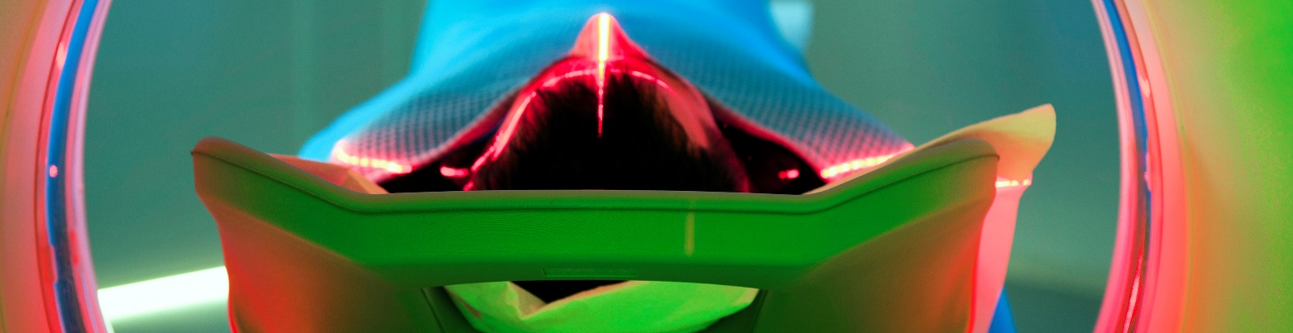

Big Thank You!

Radiation Monitor Test Programme 2025/6
We are about to send out information regarding the radiation monitor test programme for 2025/6 to the relevant contacts (mainly RPSs). If you receive this information, please read it carefully and contact radiation-protection@admin.cam.ac.uk if any problems.

Radiation Protection
Many thanks to all DSOs and facilities staff who are assisting with the radon survey.

Workplace Safety


DSE Assessment software: Cardinus Healthy Working
We are getting ready to start the implementation of Cardinus – Healthy Working across all departments. It will be rolled out over the next few months. Each department will be contacted separately by the Safety Office to discuss the process and training requirements.
This new DSE management software will replace existing paper-based systems and provide ergonomics training:
- An e-learning module covers workstation ergonomics fundamentals, including tests and quizzes for everyone required to undertake a ‘user’ assessment. A ‘user’ is anyone who regularly uses a workstation continuously for an hour or more.
- A self-assessment module helps users identify risk. This electronic risk assessment is filled in online and saved to a central database. The module will also give users practical guidance to help improve their individual workstation to give them the best set up available and help prevent future issues.
Departments will manage assessments locally using the platform database PACE, that will automatically inform users when assessments are required, and when review is needed.
Local DSE coordinators will receive all assessments for their area of responsibility. They can action issues raised on users’ assessments that could not be addressed using the self-help guidance and require further assistance, such as referral to Occupational Health.
Every department will need to identify a DSE Co-ordinator. For departments who currently do not have DSE Coordinators we have created a role profile to clarify the duties involved. It is expected that departments have a DSE coordinator per 100 DSE Users and the workload is expected to be about 1h/week once the system has been implemented into your department.
Developing a local DSE Coordinator
DSE Co-ordinators assist supervisors and managers by:
- Promoting the DSE arrangements with your teams and colleagues.
- Checking those who use DSE as part of their work have competed the online DSE Course and the DSE Self-Assessment by using the information in the PACE database
- Advising managers of the results of assessments for employees under their control and the actions they may need to take.
- Reviewing assessments with outstanding actions.
- Where the DSE user has raised concerns; agreeing any action needed with the user and their manager.
- Recording progress and any actions in PACE.
- Seeking advice from the Safety Office or Occupational Health for more complex problems (e.g. if an employee continues to experience aches and pains).

Workplace Safety
Workplace temperatures
Employers, Managers and Departmental Safety Officers (DSO’s) have a responsibility to ensure their staff are working in a safe way but also in suitable conditions for their job. Temperature is becoming even more important to consider given the increasing frequency of heatwaves that the UK has been experiencing over the last few years.
Departments should attempt to maintain the temperature at a comfortable level, however, there is no law for a maximum working temperature.

Those with low heat tolerance are more susceptible to the heat and could have an incident where they require medical attention. To help prevent this there are a range of practical actions that can be taken, most of which are cost effective, long term for everyone and require minimal effort:
- Utilising desk fans and opening windows in the workplace.
- Ensure blinds are in place and pulled down to prevent direct sunlight entering a workplace.
- Allowing staff to work from different locations or adjust their work patterns to favour cooler conditions if possible.
- Allowing staff to dress in short sleeves and shorts where appropriate and safe to do so.
- Allowing staff to come to meetings digitally such as using teams so they can be in cooler locations - this will mean making sure that rooms are booked or rescheduled to allow staff to attend.
- Rescheduling/cancelling any meetings - to be rebooked at a cooler time.
- Allowing staff more hydration breaks during their working day, offering chilled drinks/ice - having access to fridges and freezers to store personal drinks.
- Use strategically placed thermometers in buildings to assess the temperature in real time.
- Renting or buying an air conditioner unit for the department may be an option but requires correct specification and close access to an openable window to vent hot air.



Ensure blinds/curtains are in place
Allow staff to dress in short sleeves and shorts where appropriate

Biological Safety


Highlights from the Annual BSO Update Event
If you’re a member of a Departmental Safety Committee or work with GM/biological material, you may be interested in catching up with topics discussed at this year’s BSO event held on 20th May 2025, at West Hub. You can catch up on all the presentations via the links below:
- Updates and Hot Topics (Mark Wills)
- Import and Export Challenges (Rhianna Yau)
- Biosafety Training (Simon Hoer)
- Outcomes from the Biosafety Questionnaire 2024 (Rebecca Dunmore)
- Sustainability Concordat and LEAF (Jessica Richards)
- Sustainability Implementing LEAF (Emily Kempin)
We also received an insightful update from our HSE Inspectors on Contained Use Activities with GMOs, key tips include:
- Consider future notifications-new PI’s, collaborations, in vivo work.
- Proof of concept experiments- could these be done at CL1 or under someone else’s notification?
- GMSC make-up-do you have the right balance between technical/researchers and those who understand the legal requirements?
- Risk assessments-think how conclusions are applied in practice i.e. protocols or SOPs, consider non classical control measures i.e. sequencing, bioinformatics.
- Risk assessment review-capture evolution of work and make them valuable. Use realistic/proportionate review intervals.
- Departing PIs-consider materials being stored/transferred, do notifications need closing?
- Oversight-annual review of all projects to a committee, see the bigger picture and share good practice.
A big thank you to everyone who presented, attended and contributed, making this a great success. Please don’t forget to share your feedback on the event here so we can use this to plan our 2026 event!
